PHASE 8: Project Demonstration Phase
Project Team Members
M.G Misriyathul Ibrahima
S.M.B.N Meera Jenira
V.Mohana
P.Mutharasi
S.A.K. Muthu Ameena

Project: Implement Client Script & UI Policy (Incident)
ServiceNow – Incident Management

Phase Objective
To demonstrate the completed ServiceNow Incident configuration and show the behavior of the implemented controls.

Demonstration Sequence
- Open the ServiceNow Incident module.
- Create or open an Incident.
- Set Impact to 1 – High.
- Show the automatic Urgency behavior and the controlled field state.
- Leave Assigned To empty and attempt to submit to demonstrate validation.
- Provide Assigned To and submit successfully.
- Change Impact away from High to demonstrate the reverse condition.
- Open the Incident list and demonstrate the State list-edit restriction.
- Open the Incident form and demonstrate that a normal State update can be performed through the form.

Key Features Demonstrated
- Conditional field behavior using UI Policy.
- Mandatory field enforcement.
- Automatic field population using onChange.
- Save-time validation using onSubmit.
- List-edit restriction using onCellEdit.
- Normal form-based Incident updates.

Demonstration Outcome
The demonstration provides a complete end-to-end view of how the Incident configuration responds to user actions and enforces the defined rules.

Project Evidence – Screenshots
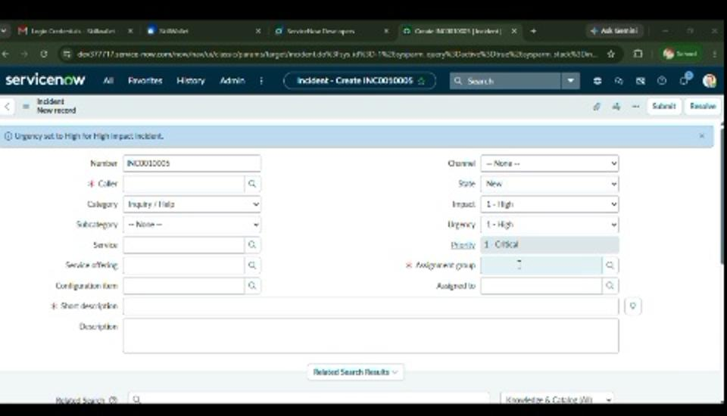
Figure 17. Incident form showing the configured High Impact behavior.
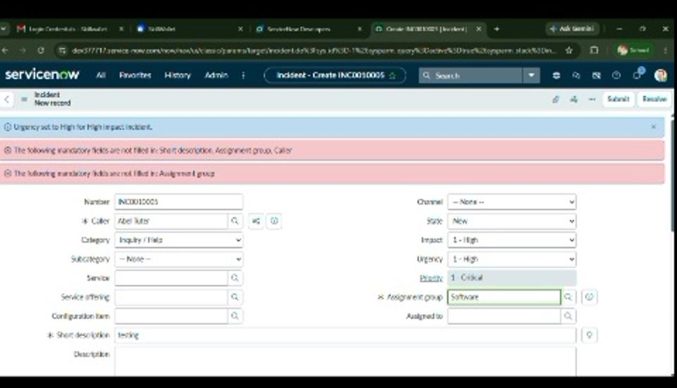
Figure 18. Validation feedback shown during the demonstration.
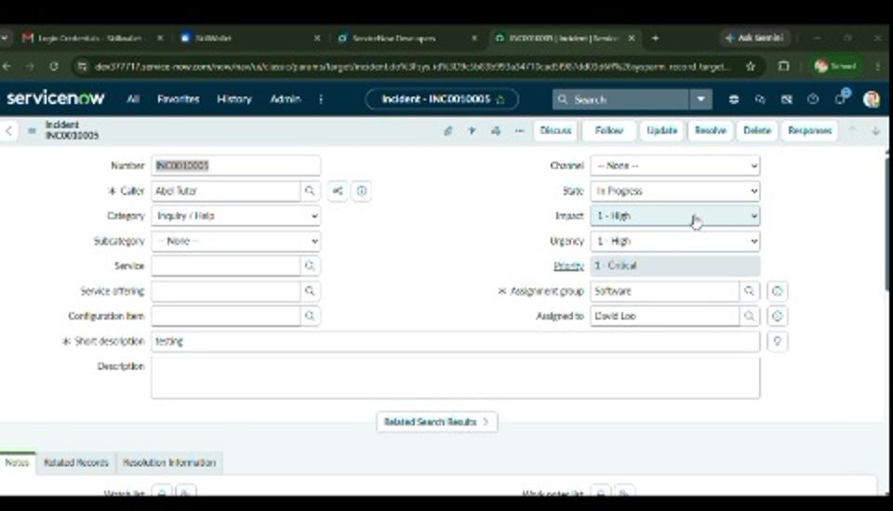
Figure 19. Updated Incident record after successful data entry.
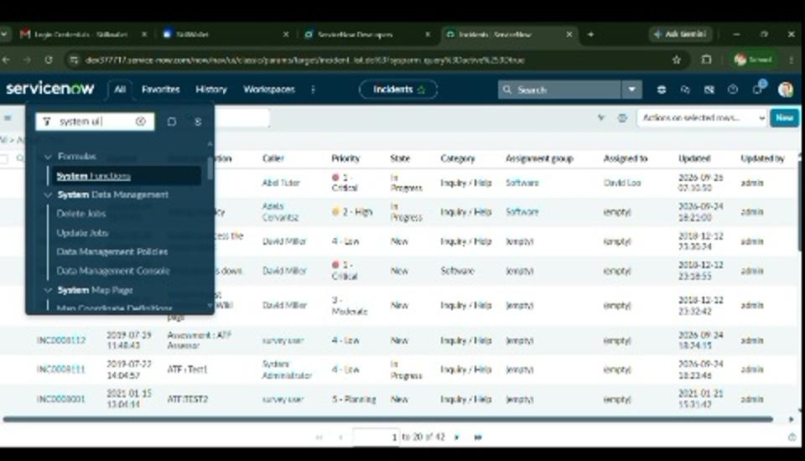
Figure 20. Incident list view used for the final demonstration.

Phase Outcome
The final demonstration flow shows the Incident configuration being applied and the resulting form/list behavior in ServiceNow.

